

Service Integration

Low Level Design

For SATS

Details the ESB design for integrating SATS Service

Version : V0.1

**Document Control**

|  |  |
| --- | --- |
| **Document Information** | |
| *Document Name* | *Low Level Design Document* |
| *Client* | *Department of e-Governance, Government of Karnataka* |
| *Document Author(s)* | *Prashanth Nuggehalli Chandrashekar* |
| *Document Version* | *V0.1* |
| *Document Status* | *Ready for Reiview* |
| *Date Last Update* | *7th July 2021* |
| *Date Released* | *12-July-2021* |

**Document Edit History**

|  |  |  |  |
| --- | --- | --- | --- |
| **Version** | **Date** | **Additions/Modifications** | **Prepared / Revised by** |
| V0.1 | 12th Jul 2021 | Initial Draft | Prashanth Chandrashekar |
|  |  |  |  |
|  |  |  |  |
|  |  |  |  |

**Document Review/Approval History**

|  |  |  |  |  |
| --- | --- | --- | --- | --- |
| **#** | **Name**  ***(Prepared By)*** | **Organization/Title**  ***(Approved By)*** | **Date**  ***(Approval Date)*** | **Comments**  ***(Description)*** |
|  |  |  |  |  |
|  |  |  |  |  |
|  |  |  |  |  |
|  |  |  |  |  |

*This page is intentionally left blank*

**Table of Contents**

**Introduction** **6**

**API Implementation Diagram** **6**

**Participating API Endpoints** **6**

**Input Output** **7**

**XAPI (Experience API)** **7**

**PAPI (Process API)** **10**

**SAPI (System API)** **14**

# Introduction

This integration is to talk to connect to SATS service and get the SATS details. The below mentioned diagram shows the context in which the API is implemented and how the conection is established to the participating services in the integration.

## API Implementation Diagram

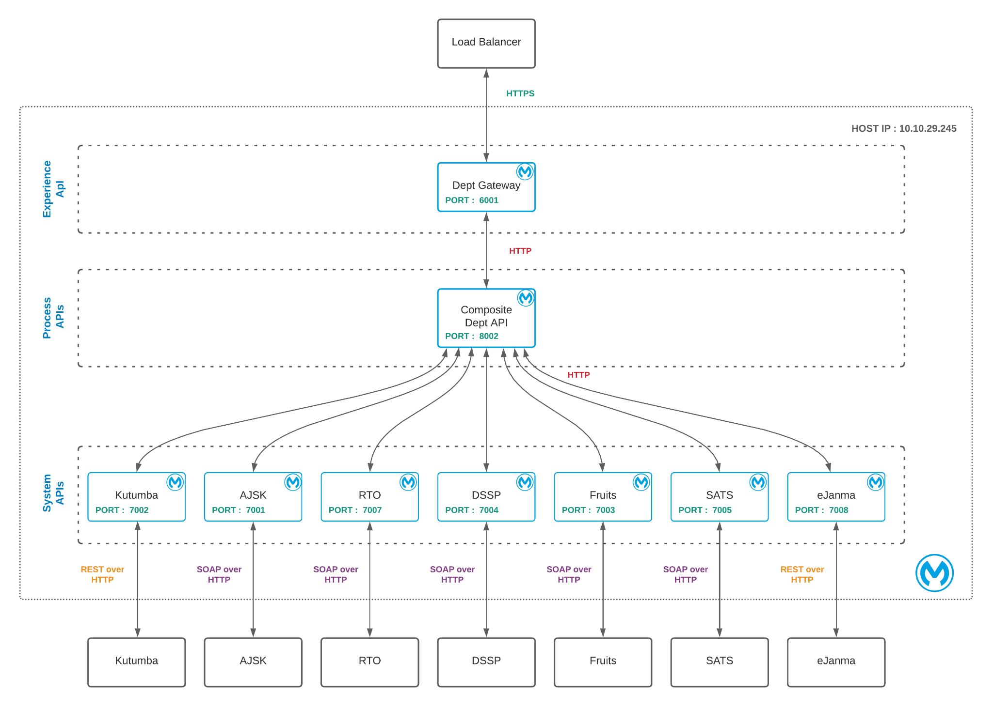

# Participating API Endpoints

|  |  |  |  |  |
| --- | --- | --- | --- | --- |
| **#** | **Name** | **URI/URL** | | |
| 1 | XAPI | http://10.10.29.245:6001/api/department/data/single | | |
| 2 | PAPI | http://10.10.29.245:8002/esb/fdb/department/single | | |
| 3 | SAPI | <http://10.10.29.245:7005/esb/sats/getFacilityDataForMahitiKanaja>  [**http://**](http://localhost:7005/esb/sats/GetFacilityData)[**10.10.29.245**](http://10.10.29.245:7005/esb/sats/getFacilityDataForMahitiKanaja)[**:7005/esb/sats/GetFacilityData**](http://localhost:7005/esb/sats/GetFacilityData)  http://[10.10.29.245](http://10.10.29.245:7005/esb/sats/getFacilityDataForMahitiKanaja):7005/esb/sats/GetAllBrcData | | |
| 4 | Destination | <http://122.170.12.200/STSWS/services/GetBeneficiaryData>  <http://122.170.12.200/STSWS/services/GetFacilityData>  **http://122.170.12.200/STSWS/services/GetAllBrcData** | | |

* XAPI Invokes >> PAPI
* PAPI Invokes >> SAPI
* SAPI Invokes >> Destination Service
* Response from Destination Service is passed to the respective callers

# Input Output

### XAPI (Experience API)

|  |  |  |
| --- | --- | --- |
| Request | | |
| http://[10.10.29.245](http://10.10.29.245:7005/esb/sats/getFacilityDataForMahitiKanaja):7005/esb/sats/GetFacilityData | | |
| {  "deptId":5,  "method":"GetFacilityData",  "creds":{  "client-id":"1234567",  "client-secret":"7654321"  }  } | | |
| Response | | |
| [  {  "facility_id": "6",  "facility_name": "Free Text Books"  },  {  "facility_id": "9",  "facility_name": "WIFS Blue Tablets Class 6 to 12 "  },  {  "facility_id": "8",  "facility_name": "WIFS Pink Tablets Class 1 to 5 "  },  {  "facility_id": "5",  "facility_name": "Shoe and Socks"  },  {  "facility_id": "4",  "facility_name": "2nd Set of Uniform"  },  {  "facility_id": "1",  "facility_name": "BiCycle"  },  {  "facility_id": "3",  "facility_name": "1st Set of Uniform"  },  {  "facility_id": "7",  "facility_name": "SHUCHI Free sanitary pads"  },  {  "facility_id": "2",  "facility_name": "Girls attandance in Class 1"  }  ] | | |
| Error | | |
| **Sample 1**   * As is Error Propagation from down stream service (This means whatever the destination service throws   **Sampe 2**  {  "httpCode": "403",  "errorType": {  "parentErrorType": {  "parentErrorType": **null**,  "identifier": "ANY",  "namespace": "MULE"  },  "identifier": "INCORRECT_CREDS",  "namespace": "SATS-CONSUMER-SYS"  },  "error": "SATS API Authentication Failure : Client Id and Client Secret does not match !",  "correlation": "7889e840-e3bd-11eb-b574-02429ea494eb"  } | | |

### PAPI (Process API)

|  |  |  |
| --- | --- | --- |
| Request | | |
| http://[10.10.29.245](http://10.10.29.245:7005/esb/sats/getFacilityDataForMahitiKanaja):7005/esb/sats/GetAllBrcData | | |
| {  "deptId":5,  "method":"GetFacilityData",  "creds":{  "client-id":"1234567",  "client-secret":"7654321"  }  } | | |
| Response | | |
| [  {  "facility_id": "6",  "facility_name": "Free Text Books"  },  {  "facility_id": "9",  "facility_name": "WIFS Blue Tablets Class 6 to 12 "  },  {  "facility_id": "8",  "facility_name": "WIFS Pink Tablets Class 1 to 5 "  },  {  "facility_id": "5",  "facility_name": "Shoe and Socks"  },  {  "facility_id": "4",  "facility_name": "2nd Set of Uniform"  },  {  "facility_id": "1",  "facility_name": "BiCycle"  },  {  "facility_id": "3",  "facility_name": "1st Set of Uniform"  },  {  "facility_id": "7",  "facility_name": "SHUCHI Free sanitary pads"  },  {  "facility_id": "2",  "facility_name": "Girls attandance in Class 1"  }  ] | | |
| Error | | |
| **Sample 1**   * As is Error Propagation from down stream service (This means whatever the destination service throws   **Sampe 2**  {  "httpCode": "403",  "errorType": {  "parentErrorType": {  "parentErrorType": **null**,  "identifier": "ANY",  "namespace": "MULE"  },  "identifier": "INCORRECT_CREDS",  "namespace": "SATS-CONSUMER-SYS"  },  "error": "SATS API Authentication Failure : Client Id and Client Secret does not match !",  "correlation": "7889e840-e3bd-11eb-b574-02429ea494eb"  } | | |

### SAPI (System API)

|  |  |  |
| --- | --- | --- |
| Request | | |
| {  "deptId":5,  "method":"GetFacilityData",  "creds":{  "client-id":"1234567",  "client-secret":"7654321"  }  } | | |
| Response | | |
| [  {  "facility_id": "6",  "facility_name": "Free Text Books"  },  {  "facility_id": "9",  "facility_name": "WIFS Blue Tablets Class 6 to 12 "  },  {  "facility_id": "8",  "facility_name": "WIFS Pink Tablets Class 1 to 5 "  },  {  "facility_id": "5",  "facility_name": "Shoe and Socks"  },  {  "facility_id": "4",  "facility_name": "2nd Set of Uniform"  },  {  "facility_id": "1",  "facility_name": "BiCycle"  },  {  "facility_id": "3",  "facility_name": "1st Set of Uniform"  },  {  "facility_id": "7",  "facility_name": "SHUCHI Free sanitary pads"  },  {  "facility_id": "2",  "facility_name": "Girls attandance in Class 1"  }  ] | | |
| Error | | |
| **Sample 1**   * As is Error Propagation from down stream service (This means whatever the destination service throws) | | |